Amundsen Sea Embayment Project (ASEP)
Science and Implementation Plan
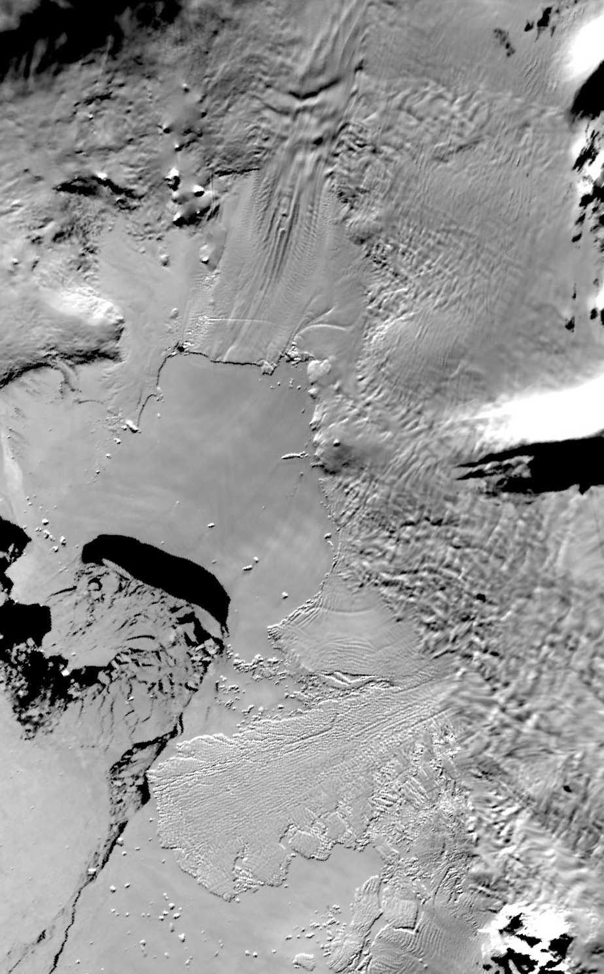
MODIS image of Pine Island Bay (center) with Pine Island Glacier (upper center) and Thwaites Glacier (lower center)

Executive Summary
The portion of West Antarctic ice sheet draining into the Amundsen Sea is melting, thinning, and retreating rapidly, contributing to global sea-level rise. These are among the largest documented changes in Antarctica. The pressing need to understand these changes and to predict their effect on global sea level and the surrounding environment can be addressed through the research in this Science and Implementation Plan, which was developed within open community science meetings over the last few years.
Satellite data have permitted reconnaissance of this area with unprecedented detail, but specific airborne, shipborne and surface field studies are essential to supply the necessary additional information to understand the cause of present changes and for accurate prediction. These field studies will be guided by the satellite data and can be conducted efficiently using research techniques refined in the West Antarctic Ice Sheet (WAIS) program.
The prediction will be made using advanced numerical models of ice flow now under development, that for the first time fully incorporate the critical flow dynamics identified during WAIS. Data collection will be guided by the needs of these models for an accurate specification of the character and history of the modern ice sheet and how it interacts with its surroundings. Elevation and surface-velocity data will be available from a number of existing and planned satellite missions, but additional data are required including: ice thickness and internal layer data from airborne radar; oceanic circulation on the continental shelf and under the numerous floating ice shelves; sea-floor morphology and sediments in the surrounding seas; distributed field measurements of accumulation, velocity and thickness change; seismic and radar probing of critical bed areas; direct sampling of the ice bed and ocean via boreholes; a geologic record of post-glacial thinning; a network of automatic weather stations; and the magnetic and gravitational potential fields of the region.
A field and funding schedule to achieve this goal in five years is attached. Three seasons of fieldwork are required followed by two years of continued data analysis and model assimilation. Total cost of the program is $16.6 million.

1. Introduction
The West Antarctic Ice Sheet is the only marine ice sheet remaining from the last glacial period. The majority of the bed is below sea level and the majority slopes downward into the interior. It has been hypothesized that this configuration implies that the ice sheet may be susceptible to run-away grounding line retreat [Weertman, 1974] leading to rapid collapse. Were this to occur, the water would raise global sea level by 5–6 meters. The multidisciplinary West Antarctic Ice Sheet (WAIS) program has been addressing this concern for the past ten years through numerous focused studies on, within and underneath the ice sheet draining into the Ross Ice Shelf [Bindschadler et al., 1999], on surrounding mountain outcrops and along the floor of the adjacent Ross Sea. A clear picture of ice-stream behavior is emerging along with a detailed history of past flow in this sector. Unsteady flow has been identified in many areas, but a rapid collapse does not appear to be underway in the Ross Sea sector. Similarly, a European initiative, the Filchner-Ronne Ice Shelf Program (FRISP) has investigated the sector of the West Antarctic Ice Sheet that flows into Ronne Ice Shelf, but not found evidence for collapse in that area either.
The third and final sector of the West Antarctic Ice Sheet is that flowing into the Amundsen Sea. So far, this sector has been only rarely visited and is relatively poorly understood. The WAIS program has, however, fostered reconnaissance studies in this sector, especially over the largest glaciers, Pine Island Glacier (PIG) and Thwaites Glacier (TG). Remoteness and difficult weather conditions both onshore and offshore have limited the study of this area for decades, but interest has persisted since Hughes [1981] identified the Amundsen Sea drainage as the most-likely site for the initiation of ice-sheet collapse. Recent satellite-based studies and research cruises of the N.B. Palmer showed that this area is undergoing major changes. These discoveries dictate that a coordinated, multidisciplinary effort be initiated in this region to assess the present trends and to predict the likely future of the ice sheet draining into the Amundsen Sea. Such a study will benefit from the successful conduct of multidisciplinary research of WAIS (http://igloo.gsfc.nasa.gov/wais), European research conducted by FRISP, coordinated research in Greenland (http://cires.colorado.edu/parca.html), as well as from the plethora of research techniques developed during these activities. A series of open community meetings coordinated with the annual WAIS meetings and extensive discussions among concerned researchers between those meetings led to this Science and Implementation Plan. This plan links directly with the field research planned for this area by the British Antarctic Survey (described in Section §6.2).

2. Overview of the Amundsen Sea Embayment
That portion of the West Antarctic ice sheet discharging into the Amundsen Sea, termed here the Amundsen Sea Embayment (ASE), covers 320,000 km², roughly 20% of the area and 20% of the total volume of the West Antarctic ice sheet (Figure 1). The ice discharge rate is much higher than in either the Ross ice streams or those feeding the Ronne Ice Shelf—the two other major West Antarctic basins. The high ASE discharge is driven by a more-vigorous snow accumulation, more rapid ice flow and more intense sub-ice-shelf melting than is usual for Antarctica. Storms circling the Antarctic continent are steered landward across the Amundsen and Bellingshausen Seas by the blocking effect of the Antarctic Peninsula. The relatively low elevations of inland West Antarctica compared with interior East Antarctica allow larger amounts of precipitation to spread farther from the coast, reaching the entire ASE catchment. These accumulation rates are some of the highest in the continent (comparable to those of the Antarctic Peninsula) suggesting that the glaciers would respond more quickly to changes in precipitation, storm tracks, and sea-ice cover.
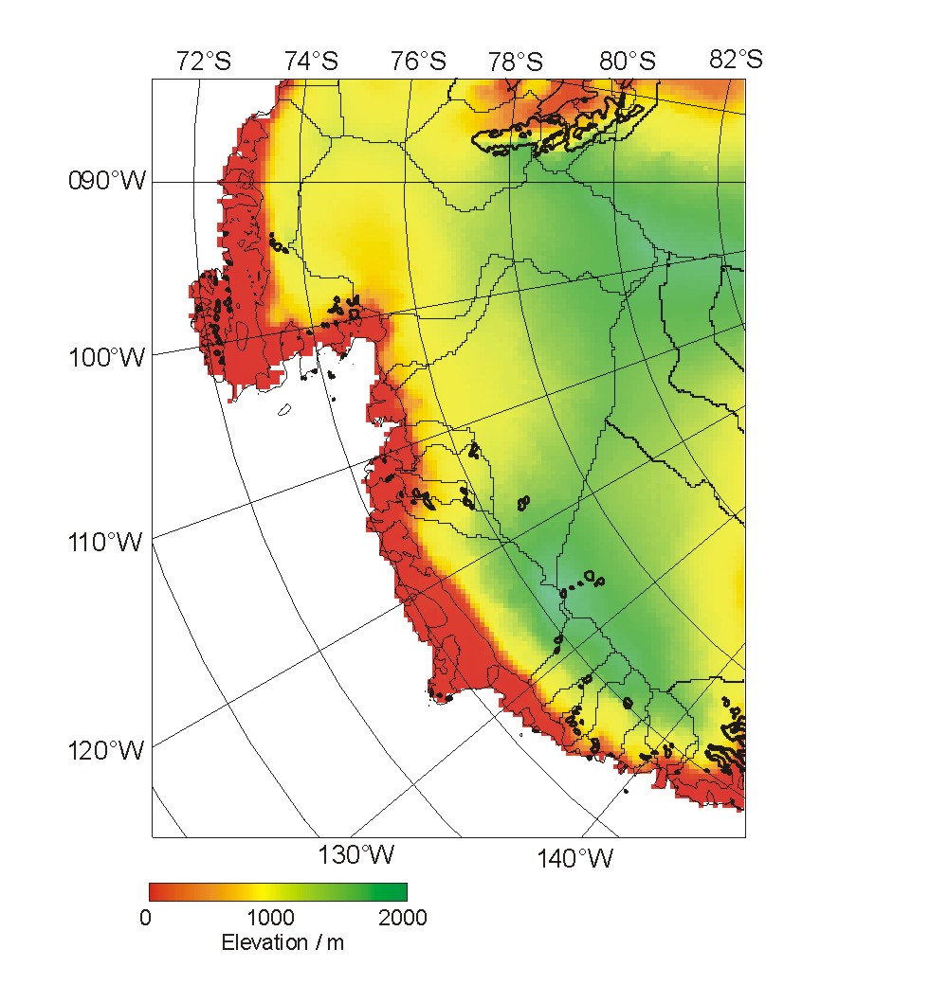
Figure 1. Surface elevation and outlines of catchment basins in the Amundsen Sea Embayment sector of West Antarctica (from Vaughan et al., 2001).
This snowfall supplies two of the fastest glaciers in the world, Pine Island Glacier (PIG) and Thwaites Glacier (TG). The PIG and TG catchments extend 600 km inland from the coast and consist of a number of smaller tributaries that coalesce 70–100km from the coast into the well-defined outlet glaciers (Figure 2). The catchment basins are deep, approaching 2000 meters below sea level in the Byrd Basin (Figure 3). Together, these two glaciers account for approximately 5% of the ice discharge of the entire Antarctic Ice Sheet [Vaughan et al., 1999].
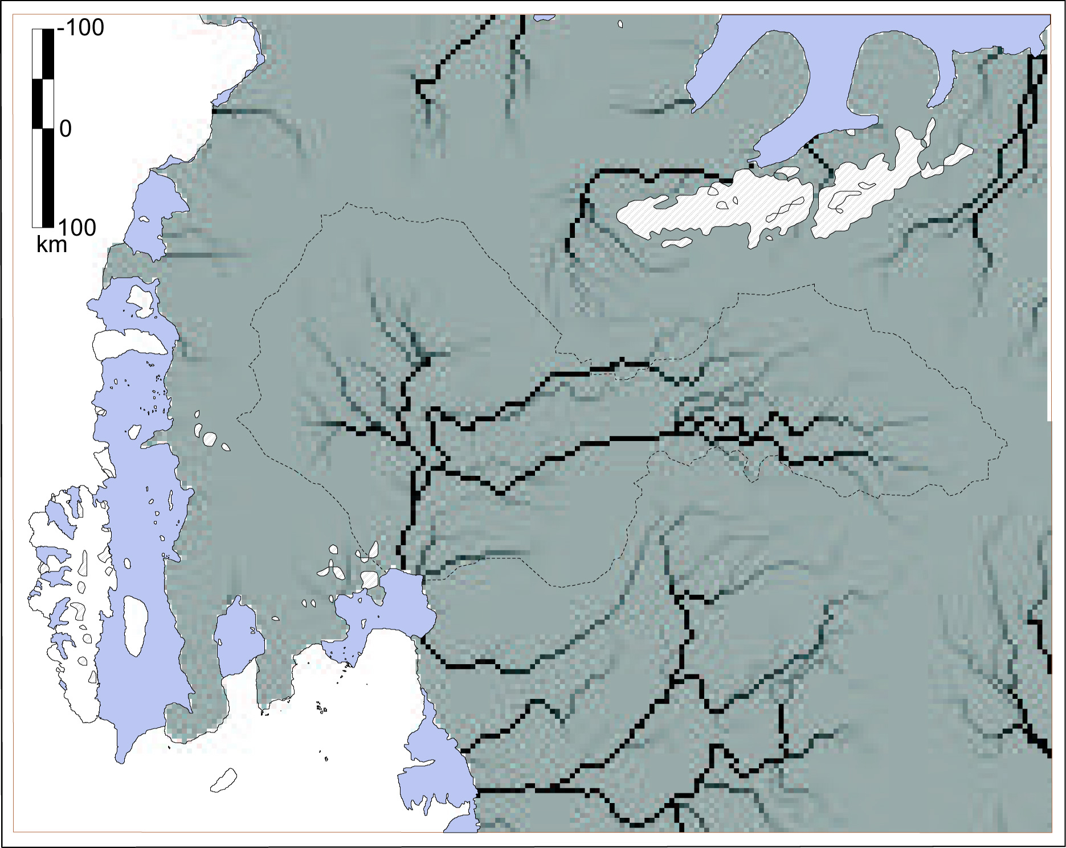
Figure 2. Flow convergence in the Amundsen Sea sector of West Antarctica represented by the darkness of individual cells. Tributary structures is evident for PIG and TG (from Vaughan et al., 2001).
The mechanism controlling the flow of these glaciers probably differs from that controlling the Ross ice streams and, perhaps, the Ronne-Filchner ice streams. Flow speeds at the transition from tributary to glacier are approximately 1 km/a rising to 2 km/a at the grounding line and rising still higher to 2.5 km/a where the floating ice shelf meets relatively warm ocean water. The driving stress in the tributaries is approximately 50 kPa, rising to more than 100 kPa near the grounding line, leading Vaughan et al. [2001] to suggest that the tributaries are akin to ice streams and the main glacier akin to an East Antarctic outlet glacier.
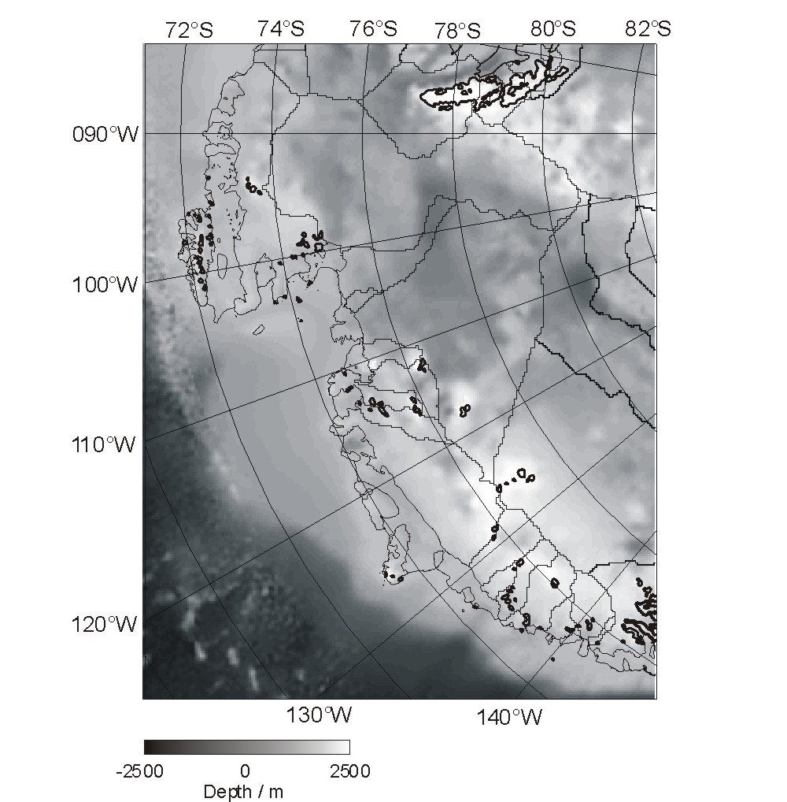
Figure 3. Bed elevation of the Amundsen Sea sector of West Antarctica (from Vaughan et al., 2001).
When the glaciers begin to float, warm ocean water is able to reach the undersides of the floating glacier tongues and cause melt at rates larger than anywhere else yet found around the Antarctic coast. The reasons for this distinction are not clear, but the close proximity of the Antarctic Circumpolar Current to the continental shelf and diminished rates of sea ice production may be responsible. The result is that exceptionally intense subglacial melting occurs throughout this area, suggesting the glaciers may be strongly influenced by oceanic processes. Large icebergs are created at the ends of the rapidly moving glaciers.
Adjacent to the PIG and TG catchments is the broad coastal catchment that feeds Getz Ice Shelf. It, too, is likely fed by high accumulation rates, but it is much thinner, rests on several large islands and has many openings to the ocean complicating the sub-shelf circulation. Discharge of Getz Ice Shelf is less defined by fast ice flow due to the lack of convergent flow within the catchment. A significant recent retreat of this ice shelf suggests it may be experiencing a similar incursion of warmer water as the floating tongues of PIG and TG. Thus, the temporal response of Getz Ice Shelf may be important in understanding the current behavior of the ASE sector.
The subglacial topography and character of the Amundsen Sea Embayment are poorly known. Traverse data, using either seismic or radar methods, and widely spaced radar-sounding flights provide the only information. Figure 4 shows the radar-souding coverage. The most recent survey from Siple Station showed complex subglacial character (roughness, internal layering, and topography) along a line that crosses from inland ice onto a tributary and then onto the main part of PIG [Vaughan et al., 2001]. This tributary appears to sit in a well-defined trough that extends down into the main trunk of PIG and has a substantially smoother bed than that of the inland ice. However, a large sill or shelf at the grounding line forces a large increase in driving stress as the glacier approaches the coast. Clearly, the geology of this region plays an important role in the configuration of the PIG/TG trunks and tributaries.
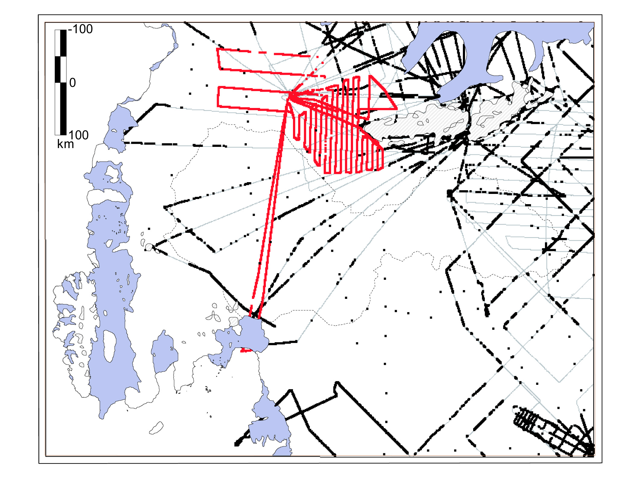
Figure 4. Radio-echo sounding coverage of the Amundsen Sea sector of West Antarctica (from Vaughan et al., 2001). Widely spaced dots are surface traverse data.

3. Temporal Behavior of the Amundsen Sea Sector
Like all of Antarctica, the ice sheet in the ASE was thicker and more extensive at the Last Glacial Maximum (LGM). Sediment cores collected on the outer continental shelf show that grounded ice extended to the continental shelf break in the Amundsen Sea during the LGM. More recent and more rapid deglaciation in the ASE has been suggested with rates of approximately 1 km/a over the last 100 years [Kellogg and Kellogg, 1987]. Indeed, deglaciation could have begun quite recently, perhaps only a few thousand years ago, with the ice still responding to this change.
The present mass balance of the region is poorly known and the few measurements are at odds. A recent mass balance estimate from comparisons of accumulation and discharge suggests the ASE region is slightly out of balance (losing 2.4 + 4 Gt/a or a surface elevation change of -1.5 + 3 cm/a) [Rignot, 1998; Vaughan et al., 2001]. Wingham et al. [1998] measured the surface elevation directly using ERS-1 altimetry and suggested a surface lowering of -11 cm/a for the time period 1992–1996 for the TG basin. This thinning is most pronounced in the TG basin but extends across the whole region. Zwally et al. [pers. comm.] obtain a similar result (Figure 5). Shepard et al. [in press] have attained an improved spatial resolution from the radar altimeter record from 1991 to 2001 (Figure 6) emphasizing that the glaciers in this region are dominant players in the overall thinning.
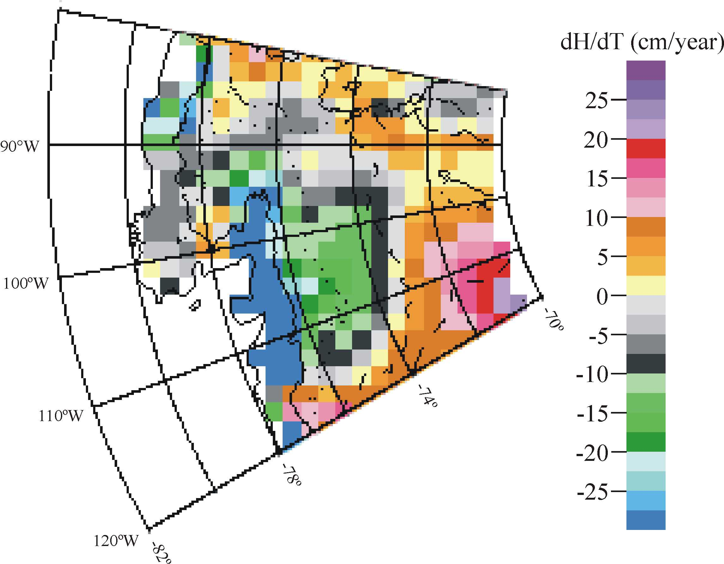
Figure 5. Surface elevation change from 1992 to 1996 from satellite radar altimetery (from Zwally et al., pers. comm.).
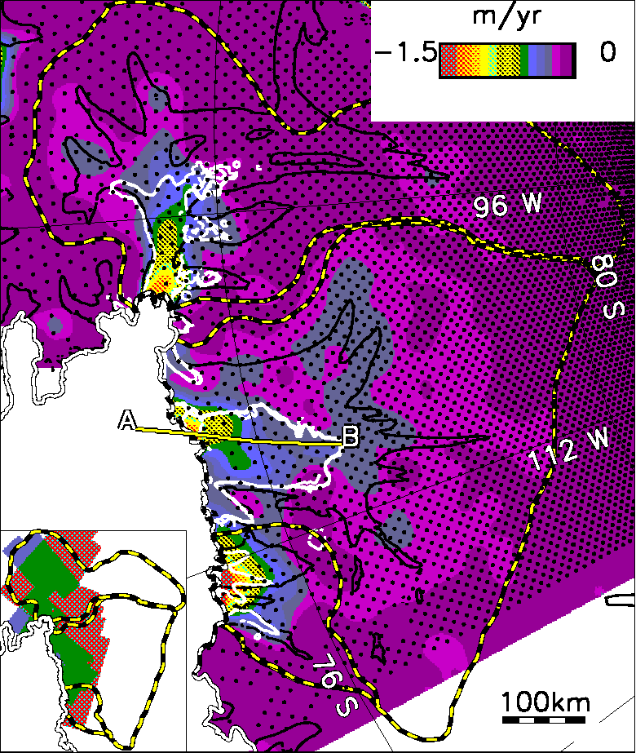
Figure 6. Rate of surface elevation change (color) in Amundsen Sea drainage basin. Dots indicate locations of ERS radar altimeter crossing-point measurements from 1991 to 2001 Contours are surface velocity (black: 50 m/a; white: 200 m/a) from interferometeric SAR coverage (image locations shown in inset) [from Shepard et al., in press].
Bentley and Giovinetto [1991] calculated an overall positive mass balance for Antarctica of 40–400 Gt/a, based in part on a positive budget of 50 Gt/a for the PIG basin. Jenkins et al. [1997] recalculated their overall mass balance assuming the PIG basin was in balance, and obtained a range of –10 to +230 Gt/a. If the PIG basin has a large negative balance, the overall budget for Antarctica would range further negative.
The most recent satellite observations of PIG and TG document substantial changes currently underway emphasizing the complexity in quantifying the mass balance of this rapidly evolving region. Satellite image analysis has allowed substantial corrections to the mapped grounding line positions of both glaciers and shown a marked retreat of each during the 1990s [Rignot, 1998]. Underneath PIG’s floating tongue, an extremely large basal melt rate exceeding 15 m/a has been calculated, more than an order of magnitude larger than most Antarctic ice-shelf basal melt rates [Jenkins et. al., 1997]. Even higher rates of melt are estimated at the grounding line. Shepherd et al. [2001] have shown that the lower portion of Pine Island Glacier is itself thinning at a rate (>1 m/a) that cannot be explained by a change in surface accumulation alone, and Rignot et al. [in press] have shown that the magnitude of this thinning is roughly what could be expected from a 10% increase in the velocity of the glacier, and that such an increase did indeed occur during the 1990s. Most recently, Shepard et al. [in press] have measured a 25-m thinning from 1991 and 2001 at the grounding line of TG and a 45-m thinning at the grounding line of the neighboring Smith Glacier (see Figure 6). Accompanying this thinning, Pine Island, Thwaites and Smith Glaciers have retreated inland 8, 4 and 7 kilometers, respectively.
Elsewhere, intense thinning, at rates of many meters per year has been documented by satellite altimetry for the Getz Ice Shelf (see Figure 5) and been inferred from Landsat imagery for the ice shelf adjacent to PIG [Bindschadler, 2001] and TG appears to have widened [Rignot et al., in press].

4. The Need for New Research
The causes for most of these startling changes in the ice sheet’s Amundsen Sea sector are not known. Multiple time scales and regional variations are involved. However, limited field observations and a wealth of new satellite data are advancing our knowledge of the area greatly. Existing models have been applied, but sparse englacial and subglacial information inhibit progress without new observational programs.
The program needed to advance our understanding of this area is described here. Developed primarily during open community meetings, it will target those areas that will produce the greatest scientific return based on existing knowledge. As with the successful parent WAIS program, this Amundsen Sea Embayment Project (ASEP) has a sharply focused scientific goal to which many disciplinary scientists can contribute.
The goal of the Amundsen Sea Embayment Project (ASEP) is to assess the present and to predict the future behavior of the Amundsen Sea Embayment sector of West Antarctica to determine its effects on the surrounding environment and global sea level.
The research described in this plan is based on what is presently known and is justified by what needs to be known to achieve this goal. This plan has been formulated over the past few years through careful consideration in a loosely knit series of scientific exchanges culminated by a one-day workshop held on September 19, 2001, immediately prior to the WAIS’01 workshop in Sterling, Virginia. The sections to follow are organized principally by data needs to facilitate the preparation of specific proposals. The implementation portion of this document (Section 7) identifies the anticipated funding and logistic resources needed to conduct ASEP.

5. Research Plan
The goal of ASEP can only be achieved by producing accurate and testable numerical simulations of ice flow that represent the dynamics of the region. Development of ice sheet models to produce these simulations will, in itself, require a significant effort supported by field measurements of the geometry of each basin, the internal, subglacial, and adjacent resistances to ice flow, the processes that add and subtract mass from the system, and investigation of possible non-linearities in the response to changes in these processes.
Significant advances in knowledge of ice dynamics, ocean dynamics and atmospheric dynamics, as well as the interactions between ice, ocean and atmosphere will also be achieved by the ASEP. While these are not specified within the explicit goal, they are necessary to the development of the predictive ice-sheet models.
Basic data sets are required. Many, such as surface elevation and velocity, are already well in hand. Others, such as ice thickness, basal conditions and composition, and internal temperature, are almost completely unknown. Still others, such as accumulation and sub-ice-shelf melting, are known approximately, but could be improved greatly and must be tested for signs of ongoing change. Thanks to WAIS, FRISP and allied programs, most of the techniques to obtain these data are already well-developed.
The first stage in model validation requires that simulation should reproduce not only the present configuration, but also the present rates of change. Thus, measurements of recent and current changes of ice-thickness, velocity, and other parameters are required. Additionally, the record of past behavior over centuries and millennia will be invaluable in constraining model behavior. This information comes from observations on nearby rock exposures, in the adjacent seas and from the tracking of internal isochronal layers. Data collected on surface traverses during and immediately following the International Geophysical Year (IGY) provide a rare opportunity for direct measurement of decadal-scale changes.
Many satellites will provide data that will contribute to the ASEP at no logistic cost, although the products of those data can be improved by limited numbers of ground control points and some validation of the products is necessary. Space-based studies are described first (§5.1), followed by discussions of airborne (§5.2), ship-based (§5.3), surface (§5.4), and modeling (§5.5) studies.

5.1 Satellite Data
The wealth of satellite data already available allows this project to proceed more directly, efficiently, and economically to its goal than any similar previous project.

5.1.1 Elevation and Elevation Change
Satellite altimetry has vastly improved our knowledge of the ice-sheet surface elevation, which is a fundamental input to the numerical models of ice flow. Elevations lead to the delineation of catchment basins and strongly influence accumulation rates, through the atmospheric lapse rate and effects on atmospheric dynamics. Repeat measurements of elevation are one of the most direct means of detecting changes in the ice sheet and quantifying mass balance of a point or a region.
Radar altimeters provide the longest record of surface elevation. Coverage in the 1970s reached only to 72ºS, but this was extended to 82ºS in the 1980s with GEOSAT and later ERS-1 and ERS-2. The interior catchment basins of PIG and TG are well-mapped and most of the PIG and TG basins are smooth enough to allow elevations precise to a few meters (Figure 1). However, elevation accuracy degrades with increasing roughness and slope, so elevation and elevation change measurements in the coastal regions are much poorer. The long record of radar altimetry observations has led to detectable trends of elevation change, particularly in West Antarctica. Figure 5 shows the recent temporal trends throughout different basins. ENVISAT will continue the series of radar altimeters.
Scheduled for launch in late-2002, ICESat will carry a laser altimeter into near-polar orbit. More precise in range and narrower in footprint than conventional radar altimeters, this altimeter will open a new era in spaceborne altimetry. With a 186-day repeat cycle, the spacing between orbits will be much less than with existing or planned radar altimeters. Clouds will hinder data collection and degrade the coverage; however, multiple orbits over the PIG and TG will occur every day. Methods will need to be developed to extend the utility of the new laser measurements including comparing them to the wide-footprint radar measurements, incorporation of postglacial rebound of the underlying bed from gravity measurements of the GRACE satellite, and using optical imagery to interpolate laser-based elevations to off-nadir positions. Ground measurements (§5.4.1 and 5.4.2) will provide control to verify accuracy of ICESat and GRACE data. Repeated seismic measurements at sites occupied over 40 years ago (§5.4.1) will independently address the inference of ice-thickness change from surface elevation change.
Projected for launch in 2004, is the CryoSat mission planned by ESA that will carry a radar altimeter that uses a SAR technique to reduce the effective footprint of the altimeter. This satellite will provide all-weather measurement of ice surface elevation over a 3-year lifetime.

5.1.2 Velocity
Models and ice dynamics studies require the velocity field. Repeated optical and synthetic aperture radar (SAR) imagery have provided broad spatial and temporal coverage of surface velocities within the PIG and TG catchments. Feature tracking is the common method employed with optical imagery. The 28-year record of Landsat observations has illustrated some of the changes that PIG has undergone [Bindschadler, 2001]. There is strong evidence that the glacier has accelerated and its floating tongue has widened.
SAR images have been analyzed using interferometric techniques to map the surface velocity over much of PIG’s catchment basin [Rignot et al., in press]. Where speeds are too high for interferometric techniques, the radar speckle can be tracked in a manner similar to feature tracking with optical imagery. The results have illustrated that PIG is fed by as many as ten significant tributaries (see Figure 2). Whether these tributaries correspond to subglacial valleys, as with the Ross ice streams, is unknown because the basal topography remains poorly mapped (§5.2.1).
Future prospects for high-resolution optical imagery are excellent. The larger changes in velocity are expected at the coast where optical imagery is most useful and trackable features are most abundant. Landsat and similar, but smaller field-of-view sensors SPOT and ASTER, are planned to continue into the foreseeable future.
SAR sensors will also continue and are necessary to monitor velocity over the large featureless areas. Current and planned SARs only look northward, limiting the coverage to about 79ºS. Further limitations to applications of interferometric SAR techniques may come from the expected long period between repeat orbits and poor orbit control. Speckle-tracking is less constrained and with its ability to penetrate cloud and image at night may be the most dependable method for monitoring velocity, not to mention changes in grounding line position.

5.1.3 Accumulation
Snow accumulation is the principal source of mass input to the ice sheet and must be known accurately. Generally, uncertainties in accumulation are a major error in calculations of ice-sheet mass balance, and seasonal and interannual variability in accumulation rate must be removed in order to expose long-term trends in satellite altimetry measurements of surface elevation. Although accumulation has not been measured directly from space, passive-microwave emissivity variations have been used to interpolate between ground measurements of accumulation rate [Giovinetto and Zwally, 2000]. This has been particularly valuable in the TG basin, and to a lesser extent in the PIG basin, because ground measurements of accumulation are very sparse (Figure 4).
A close tie is needed between satellite and ground measurements. There already is nearly a 30-year record of microwave emissivity variations in the polar regions. Once shallow cores are collected and analyzed accurately (§5.4.1), the records can be compared to improve the matches between the core stratigraphy and the emissivity record. This should strengthen the spatial interpolations of accumulation measurements.
ICESat also holds promise in measuring single accumulation events. Combinations of these sensors may help illuminate specific causes of temporal changes in emissivity that occur as the snowpack evolves.
“Coffee-can” measurements of the type being undertaken by the US-ITASE traverse through the PIG and TG catchment basins (§6.1), and being proposed by UK researchers for Ellsworth Land are unambiguous point measurements of ice sheet mass balance. Although point measurements, they are important from the point of view of verification and understanding of the short-term trends determined by 3-5 year satellite missions.

5.1.4 Surface Temperature
Knowledge of surface temperatures in the ASE region would assist modeling and data interpretation.
Large temperature increases, possibly linked to climate warming, have been documented on the west side of the Antarctic Peninsula [King, 1994]. At the Byrd Station automatic weather station (AWS) further inland, data on near-surface temperature are beginning to define a climate baseline, however, these site-specific data have significant gaps and may not be representative of broader regional or continental-scale patterns. Ten-meter temperatures from IGY-era traverses provide unique opportunities for temperature change detection at selected locations (§5.4.1).
Temperature fields derived from satellite infrared measurements [Comiso, 2000] or passive microwave sensors could provide a much more complete characterization of spatial and temporal variations in Antarctic temperature over the past 20 years. Currently, the only spatially detailed record of surface temperature across Antarctica is provided by Advanced Very High Resolution Radiometer's (AVHRR) infrared radiometry, but these data must be processed carefully to remove the effects of clouds.
Passive microwave data from the 37 GHz channel of the Special Sensor Microwave/Imager (SSM/I) are not influenced by cloud-cover and can be calibrated at specific AWS locations or by radiative transfer models, but cannot yet be broadly extrapolated in space and time because of still poorly understood spatial variations in the emissivity of the surface. Time series of these satellite data, if they could be used consistently, would provide the needed temperature data to identify regional and continental-scale climate change across Antarctica.
Installation of an AWS network in the ASE region, primarily at core sites likely to be revisited over the 3-5 year time frame would enable insights into the accuracy of the retrieved surface temperatures from satellite infrared and microwave sources and establish confidence limits on these data.

5.2 Airborne Data
Airborne instruments are an alternative means to measure large areas. Unlike satellites, the coverage grid can be designed to optimize the placement of the measurements for a range of scientific studies.

5.2.1 Ice Thickness and Internal Layers
Even the simplest analysis of ice flow requires knowledge of ice thickness. More-sophisticated simulations require more-detailed information. Airborne radar sounding, located by onboard precision GPS, is the most efficient means to collect these critical data.
The recent BEDMAP compilation [Lythe et al., 2001] shows there are major gaps in the knowledge of ice thickness in this area. The few available airborne soundings, augmented by limited traverse data, indicate that the interior PIG and TG catchments occupy deep basins within the West Antarctic Rift System (Figure 3). The glaciers themselves overrun the confining highlands north of the deep basins possibly being channeled by valleys within this mountainous region. This geologic situation probably dictates the location of where these glaciers exit the ice sheet.
The existing airborne profiles hint at surprising behavior. The bed underneath the interior ice is typical rugged West Antarctic terrain, but this changes dramatically to a much smoother bed underneath a faster flowing tributary that eventually becomes the PIG. Many more tributaries have been mapped from satellite SAR interferometry (§5.1.2), but no others have been sounded by radar. It appears the tributaries share some characteristics with the ice streams feeding the Ross Ice Shelf. Whether the PIG and TG tributaries sit in subglacial troughs can only be determined by additional radar measurements.
Suitably designed airborne radar campaigns collect important data on internal layers. Disruption of these isochrones demonstrates flow disturbances. In the broad regions where the layers are not disturbed, they can be used to calibrate and verify numerical models. Layer tracing between profiles reveals the three-dimensional character of ice flow. If any profile intersects the location of a well-dated ice core, the isochrones can be assigned absolute dates. This enables quantification of the relative contribution of basal sliding to ice motion and an ability to measure basal melting, where present. This additional information has rarely been available to numerical models, but is essential to improving model performance. Excellent imaging of internal layers must be a requirement of any airborne-radar program.
If the ice-penetrating radar is well calibrated and coherent, the dielectric properties of the bed can be quantified. This provides a measure of the bed properties and whether the bed is wet or frozen. This is of obvious importance to the modeling effort.
In a study of ice-sheet response, the faster-moving areas and the areas where flow transitions occur are of central concern. Fortunately, satellite data have mapped these. This information permits the design of a flightline network that optimizes the logistic efficiency of collecting the information described above. With proper onboard GPS navigation, flowlines can be followed over their entire length, giving flowline models an unprecedented data set of ice thicknesses, internal layers and bed conditions. Areas of flow transition, both at the margins of tributaries and at their onsets and transitions to streaming flow and ice shelf flow, can be targeted with concentrated flight surveys. The less-important interior basins and slower flowing ice must be sampled, but with increased spacing between flightlines. The floating tongues must not be overlooked. The detection of bottom crevasses can be related to the dynamics and history of the ice shelves.

5.2.2 Gravity and Magnetics
Several characteristics of the Amundsen Sea Embayment suggest that the geology is important to the ultimate expression of ice dynamics. These characteristics include: the change in the character of the bed from the inland regions to the tributary; the channeling of flow in the coastal mountains; the possible presence of widespread marine sediment drape and fault-bounded rift basins; and the occurrence of volcanoes in the region, implying high geothermal heat flux.
Tectonic elements beneath the WAIS include the boundary between Thurston Island and Marie Byrd Land. This is a large but poorly mapped segment of the West Antarctic rift system, the central Marie Byrd Land volcanic province of Neogene age, and major oceanic transform faults offshore. There are indications of active faulting and young volcanism (Oligocene and younger), with potential for significant influence on thermal conditions. These structures likely influence the basal thermal regimes and thus ice flow.
PIG and TG appear to transect the structural grain and tectonic margin of the West Antarctic Rift System and the flank of the Byrd Subglacial Basin. This contrasts with the Ross ice streams, where glacier flow is parallel to rift structures. This transverse orientation may explain the occurrence of ice-marginal sills that may have helped stabilize these outlet glaciers.
Airborne gravity and magnetic surveys are the most efficient means of mapping the bedrock geology beneath the ice of the ASE region, and such surveys have been conducted from the same aircraft as radar and laser-altimetry surveys. Onshore airborne geophysical surveys would be coordinated with seafloor mapping (§5.3.2) to match structures across the coast. Virtually no information of this type is now available.
An important aspect of efficient airborne surveys of this type is that lines are flown in a grid pattern to define tectonic grain and volcanic centers adequately. This is in contrast to what was proposed above as the most efficient strategy for collecting radar-sounding data. Non-gridded geophysical data may be of some value, but lines must be straight to minimize aircraft-induced accelerations to the gravimeter. A grid spacing of 5.6 kilometers has provided superb data elsewhere in West Antarctica, however this spacing need only apply to flightlines in one orientation—tie-lines can be separated by many times this spacing to extend data coverage.

5.2.3 Laser
Airborne surveying also provides an opportunity to collect accurate surface elevations by airborne laser altimeters. Many systems, either scanning or nadir-locked, have been used over glaciers and ice sheets. By collecting data only in cloud-free regions, the data set avoids the discontinuous character expected from satellite altimetry (§5.1.1). Selected airborne-laser profiles could be oriented to validate satellite altimeter measurements.
Unlike the other airborne data sets described above, airborne laser altimetry for elevation-change detection requires resurvey at some later time. A hiatus of many years is desired between surveys to minimize the effect of interannual variability of snow accumulation. Airborne laser surveys separated by five years produced unique and exciting results in Greenland [Krabill et al., 1999].

5.3 Shipborne Data

5.3.1 Oceanic Circulation and Heat Exchange
The oceanographic conditions in the Amundsen Sea are quite distinct from those of the Ross and Weddell Seas. Average melt rates underneath the PIG shelf are ~20 m/a, two orders of magnitude higher than under the Ross Ice Shelf. Contributing factors include the intrusion and circulation of relatively warm Circumpolar Deep Water (CDW) on the continental shelf, a short circulation path length of CDW under the Amundsen shelf ice, the relatively deep draft of the PIG, and the general absence of dense, cold shelf-water production on the Amundsen Sea continental shelf.
In the Amundsen Sea, relatively warm CDW floods the deeper portions of the continental shelf. Recent surveys show relatively warm water near the fronts of fringing ice shelves, no well-developed oceanic slope front near the continental shelf break, major glacial troughs on the shelf, myriads of icebergs, and diverse sea-ice cover. Cooler, fresher water, generated from melting of the undersides of ice shelves and sea ice, overlies the CDW and dominates the shelf water columns farther west. The strong salinity contrasts determine the density structure that drives the thermohaline circulation. Sea ice extent has recently declined substantially in this sector and in the adjacent Bellingshausen Sea. Increases in ocean temperature and melting are likely to increase the ocean stratification and reduce the vertical heat flux. This could negatively impact the ice shelves if they melt faster because more heat is retained in the CDW.
Ocean depths at the grounding lines determine the melting potential, a function of the temperature difference between the in situ freezing point and the inflowing CDW. Mean circulation under the floating ice must be modeled to determine the distribution of melting and where melt products are removed from the cavity. More accurate sub-ice cavity dimensions are needed for successful numerical modeling. Marine ice probably does not form on the bottom sides of these ice shelves, since the outflows have been measured to be more than a degree above the in situ freezing point, but the role of large basal flutes is not well understood.
Tidal amplitudes must be measured for the removal of tides from satellite altimetry and SAR, along with tidal currents, a source of turbulent mixing at the ice base that will modifying the sub-ice heat balance. Such measurements are also needed for the validation of tidal models before accurate predictions of future change can be obtained.
Repeated temperature-salinity-depth (CTD), ocean chemistry, and ocean current data are needed along the ice front and over the adjacent continental shelf, coupled with multiyear current and CTD moorings. The mean and variability of heat transport from the Antarctic Circumpolar Current to the ice front must be determined along with the distribution of water freshened by ice melt. Coupling between precipitation, the sea-ice and the shelf-resident water must be studied, as this affects the potential for water mass modification of CDW as it crosses the shelf.
Modeling experiments have shown that changes in ocean thermohaline characteristics could produce shifts in the strength of the sub-ice circulations. Because the seawater freezing point falls with increasing pressure, melting rates could increase if the grounding lines retreated into deeper basins. Basal sills could prevent the penetration of CDW, depending on their height versus the thickness of the warm inflows.
Numerical models based on data assimilation provide the best way to assess the ice-sheet's response to changing oceanic conditions. Additional bathymetry and sub-ice-shelf water-column measurements would also allow the first meaningful assessment of whether ice-shelf buttressing is an important stress component in influencing ice flow in some or all phases of ice retreat or growth. Various models now exist, running in both idealized 2-D and 3-D configurations. The models are sensitive to prescribed open-ocean boundary conditions and to prescribed cavity geometry, both only roughly known.
Coincident time series of sea-ice concentration and extent (from passive microwave satellites, §5.1.3), weather patterns (from moderate resolution satellites, §5.1.4), and accumulation rates (from shallow cores, §5.4.1 and 6.1) may allow a meaningful study of the extent to which sea ice conditions affect accumulation rates. This interaction is often mentioned in ice-sheet/climate studies but is not understood well. Automatic weather stations (§5.4.5) could help extract wind information from the satellite imagery.
Apart from the obvious difficulties of obtaining data under PIG and TG, ocean access to Pine Island Bay PIB) and the Amundsen Sea shelf north of Pine Island Bay can be difficult because of frequent thick pack and fast ice, even in the austral summer. In situ measurements will be attempted in early-2003 by the British AUTOSUB (http://www.nerc.ac.uk/ms/Autosub/), a programmed autonomous submarine research vessel as part of BAS research in this area (§6.2). AUTOSUB may prove to be a valuable tool not only for the sub-shelf-ice cavity but also for data collection under heavy sea ice. Additional help for vessel access to critical areas could be obtained from USCG icebreakers and other vessels that have superior ice cutting capabilities to the two NSF research vessels Palmer and Gould, and the AUTOSUB tender, J.C. Ross. In addition, the Alfred Wegener Institute plans a major marine geophysical and geology program in the ASE in either 2004-05 or 2005-06 (§6.5)

5.3.2 Seafloor Morphology and Retreat History
Evidence of past ice-sheet grounding, the method of ice flow, and the rate of ice-sheet retreat all can be studied using equipment based on a research vessel. The ice sheets deposit sedimentary material and rework this material when they advance over it. The structure and stratigraphy of this sediment furnish a record of glacial and glacial-marine conditions at the time of deposition and possible clues to the roles that subglacial water, deforming till, and bedrock geology may play in the dynamics of ice-stream motion. By dating the core material and by evaluating the composition and character of the sediments, the age of key units can be determined. From this information, the rates and patterns of ice-sheet retreat can be inferred. The methods used are multi-beam swath bathymetry and side-scan sonar for sea floor morphology, seismic studies for stratigraphy, and coring/drilling for paleoclimate and timing data.
Piston cores of glacial and glacio-marine sedimentation on the continental shelf, slope and rise provide a record of the distribution, size and dynamics of ice streams through the Quaternary. Because the rate of marine sedimentation in the area is relatively low, piston cores are capable of extending through the Holocene sediments and sampling sediments from the last glacial period. Paleontological techniques provide information on the bottom water characteristics (e.g., temperature, bathymetry, and proximity to grounded ice), upper water mass characteristics (e.g., presence or absence of glacial ice, salinity, light, mixing, and primary productivity), and terrestrial palynology (e.g., vegetation characteristics, spores and pollen). Deeper, crustal-scale investigations determine the geologic and tectonic controls on basin distribution, areas of high heat flow and boundaries between terrains, all of which are likely to influence ice dynamics.
Surveys in Pine Island Bay and smaller outlets in the Amundsen Sea identified the presence of outlet troughs and confirmed that the grounded ice sheet extended at least to the middle of the continental shelf during the Last Glacial Maximum. Detailed sedimentological studies of piston cores collected during these surveys will help to locate former grounding-line positions and the paleodrainage divides of former ice sheets, including the presence and course of large meltwater channels, and will allow studies of the nature of ice-sheet retreat from the shelf. Studies are being conducted to evaluate methods of age-dating these sediments so that the actual timing of ice-sheet retreat from the continental shelf can be established and to extract information of water mass characteristics and terrestrial palynology listed above. Age dating of the contact between subglacial and glacial marine sediments in these cores will rely on the most current radiometric dating methods (i.e., Tandem Accelerator Mass Spectrometry: TAMS) and may provide a record of the timing and rate of ice-sheet retreat.
These data will reveal the glacial-maximum configuration and retreat history of the ice, necessary as inputs and for testing ice-flow models.

5.4 Surface Field Work
Irrespective of the breadth, quality and value of the satellite and airborne data, a number of surface-based observations are mandatory. The value of these studies extends well beyond their use in validating remotely collected data sets.

5.4.1 Shallow cores and ground-based radar
Shallow cores access the most recent past and make possible the quantification of accumulation events and temperature. High-quality accumulation rate data, encompassing both spatial and temporal variability, are necessary for a proper understanding of the mass balance of PIG and TG and as a fundamental boundary condition in numerical models. Long-term accumulation rates are best derived from a well-distributed series of 20 to 200-meter deep ice cores. The large accumulation rates in this region of West Antarctica require cores at least 35 m deep to recover ~40-year records (using radioactive fallout layers from atmospheric atomic bomb testing as reference horizons). Accumulation is large enough that annual layers can be counted directly providing records of interannual and decadal-scale variability. Temporal and spatial variability, when combined with the records of sea-ice extent and meteorological information, may provide some insight into the factors causing accumulation variability. These factors can be incorporated into the model predictions of future ice-sheet behavior.
It is unlikely that ice cores alone will be spaced closely enough to capture important spatial patterns in accumulation that are known to occur at the 2-10 km scale. US ITASE (§6.1) has demonstrated success in profiling firn stratigraphy and deeper internal layers over several hundred kilometers between coring sites using ground-penetrating radar. Simultaneously-collected GPS data provide geolocation and topographic corrections, while the ice cores provide density and dating controls.
US ITASE will be collecting numerous shallow cores through much of the ASE area, but their locations are not optimized for study of the ASE ice dynamics. Some additional cores will be necessary, especially at sites closer to the coast where the passive microwave satellite data (§5.1.3) suggest large spatial gradients of accumulation.
The large accumulation rates are suitable for deriving high-resolution paleoclimate records. These records will be used to address questions of natural variability (e.g. ENSO) and anthropogenic-induced changes in climate of the ASE region of Antarctica.
Some former IGY sites (widely spaced dots in Figure 4) must be revisited where ten-meter temperatures, regarded as an accurate equivalent of the mean annual air temperature, and seismic measurements of ice thickness (§5.4.3) afford the unique opportunity to detect changes over a temporal baseline of more than 40 years. Decadal-scale warming is documented on the Antarctic Peninsula and similar trends, if found in West Antarctica, would be equally significant. Accuracy of these temperature data is approximately 0.1ºC [Brecher, pers. comm.] and station locations are accurate to about 250 meters [Chapman, pers. comm.].
Internal layer information is of such critical value (§5.2.1) that there is need for a separate deeper penetrating ground-based radar system that can link the airborne radar internal layers directly to the shallow core accumulation record. Deep ground-based radar will also be important as a record that parallels the shallower radar.

5.4.2 GPS Control Sites
GPS observations on the ice sheet serve several functions. Precise positions provide control on elevation, and repeat surveys provide elevation changes and velocities. These observations are important in their own right, but they also serve as the critical validation element for numerous satellite measurements, including ICESat laser altimetry (§5.1.1) and interferometric SAR (§5.1.2) For logistic efficiency, GPS surveys can be collocated at sites where shallow coring is conducted (§5.4.1), as is done during US ITASE. Continuous kinematic profiling can also be conducted by overland traverses. In some cases, quick GPS receiver deployments via Twin Otter could augment the velocity data set and examine the possibility of tidal influences on ice speed.
GPS measurements tied to reference markers frozen into the near-surface firn are a means of directly measuring local rates of ice thickness change. The technique requires ancillary measurements: a vertical density profile and accumulation rate are used to correct for firn compaction around the buried markers, and surface ice velocity and topography are used to correct for horizontal advection of the markers. These measurements are most efficiently done where control velocity and elevation measurements are collected. The method is simple and quick, although repeat occupations a year or more apart are required to obtain vertical velocities.
This technique has been applied elsewhere in Antarctica and Greenland. The results have small uncertainties and apply to longer-term timescales than the few years corresponding to altimeter-based methods (§5.1.1 and §5.2.3). At selected sites, the measurements can be integrated with a modified automatic weather station (AWS; §5.4.5), to couple long-term changes in ice thickness to short-period fluctuations in surface elevation change caused by snowfall and firn compaction. This information is an important aid for the interpretation of altimetry results.

5.4.3 Seismic Probing
Numerous prior studies have demonstrated the value of high-resolution seismic reflection experiments over the ice-covered regions of Antarctica. This technique can be used to characterize regional glacial and subglacial conditions at scales ranging from meters to kilometers. Our experiments are designed to characterize the englacial and near-subglacial environment of the PIG and TG. Accurate modeling of the glaciers requires accurate physical properties of the ice and proper characterization of the subglacial environment. The fabric within the ice and the presence of entrained morainal (freeze-on) material can significantly affect the flow law for ice. The subglacial environment is clearly key to the ice streams of the Siple Coast, and we hypothesize that it will be important for the ASE glaciers as well.
These data can only be gathered by seismic methods. To characterize the englacial (changes in fabric, entrained material from freeze-on) and subglacial layer properties (porosity, water pressure and acoustic impedance), both compressional- and shear-wave velocities must be measured at selected spots on the glaciers. A star-pattern survey (three intersecting lines that form 120-degree angles to each other) can be used to determine and account for the large anisotropy within the ice sheet. A typical length of each line is approximately 6 km, and should include both vertical and horizontal geophones.
Locations of these surface experiments can be determined best once the airborne data sets are in hand. Combining this information with the surface ice velocity data will give researchers a guide to the most productive areas for seismic studies. At least four sites are required to sample the major regions: one site on each of PIG and TG; one site on the inland ice; and one site on the inter-stream ridge between the glaciers. These experiments will characterize both the subglacial layering properties (presence or absence of till and/or sedimentary layers) as well as determining the ice fabric (from anisotropy) and entrained morainal materials from possible freeze-on in the various regions.
These experiments will use the reflectivity method, as well as travel-time techniques and refraction methods to characterize the subglacial and englacial environments. The scale of work is such that the logistical effort can be supported with Twin Otters and helicopters.
Repeated seismic measurements of ice thickness collected over 40 years ago at sites roughly 100 km upstream of the grounding lines of PIG and TG [Behrendt et al., 1962] allow an independent check of ice thickness measured by airborne radar (§5.2.1) and ice thickness change inferred from satellite altimetry (§5.1.1).

5.4.4 Glacial Geology
Although it is imperative to understand what the PIG and TG are doing now, it is also important to place these changes in a historical context. Is the current thinning part of a long-term trend or does it mark the end of a period of stability? Geological evidence on the ground offers the best direct evidence of past maximum glacial thickness and postglacial retreat. Trimlines and glacial moraines directly constrain past ice margins and thickness. Till and striated bedrock (or the lack of them) give information on basal conditions. This information is essential to constrain boundary conditions for dynamic ice sheet models.
Chronology is supplied by cosmogenic surface exposure dating. This technique measures the length of time a rock has been exposed on the surface to cosmic rays by measuring the concentration of cosmogenic nuclides (³He, ¹⁰Be, ³⁶Cl) in the rock. The technique is well suited to Antarctica and has already placed significant constraints on past WAIS behavior. Age versus elevation data provide a vertical history of ice retreat and beautifully complement the horizontal retreat history extracted from the seafloor stratigraphy (§5.3.2). Together they can allow inferences of past ice dynamics. There are many exposed nunataks in the area of PIG, but fewer in the TG area. Some of the best opportunities may be on the islands offshore. Cosmogenic exposure ages indicating when the islands became ice-free may provide the best constraints on ice margin retreat, as ¹⁴C chronology has been difficult to obtain from the marine sediments.
Applying these techniques requires access to ice free areas throughout the PIG and TG drainages for detailed mapping and collection of samples for dating. Mapping would be greatly facilitated by aerial photography that presently does not exist, or by very-high-resolution imagery (i.e., one-meter or less). Coastal outcrops are best reached by ship-based helicopter support. Such support could also be used to reach many of the nunataks. Alternative support for inland sites would be Twin Otter supported field camps with snowmobiles.

5.4.5 AWS
Most of the precipitation in West Antarctica crosses the coasts of the Bellingshausen and Amundsen Seas. The Amundsen Sea sector of the Antarctic is believed to be the most sensitive to interannual variability in the form of teleconnections to the globe-girdling El Niño/Southern Oscillation (ENSO). This implies complex feedbacks between atmosphere, ocean and snow accumulation. A persistent low-pressure center off the coast in the southeast Pacific facilitates inland moisture transport and causes a peak in ice accumulation along the West Antarctic coast and within the interior.

There are currently no meteorological stations in the interior of the Amundsen Sea sector. Compilations of accumulation or temperature lack the level of detail needed for accurate modeling. Results of fully coupled GCMs must be qualified by the current lack of data from much of the region.
Direct measurements of wind speed, wind direction, and temperature would substantially augment the data set connecting meteorological observables with measurements of accumulation rate. In addition, weather data, such as cloudiness, wind speed and surface conditions, are needed for realistic logistics planning. Some of these data can be obtained by satellite imagery but ground stations need to be established at key locations to assist in forecasting and in remote field operations.
One AWS was successfully installed at the Amundsen/Ross flow divide during the 1999/2000 Antarctic field season in preparation for a future U.S. deep ice coring operation. An additional three AWSs were installed along a 50 km transect close to the Amundsen/Ross ice divide in November 2000 by US ITASE. These stations are modified to include studies of firn compaction (§5.4.2).
In the recent past, there have been some offshore AWSs located on islands in the Amundsen Sea. These are no longer active, but the US Coast Guard might be able to assist in reestablishing AWSs in this critical area of moisture transport to the ice sheet.

5.4.6 Boreholes
Drilling allows access to the bed where direct observations can be made. This method is ultimately needed to confirm hypotheses about ice dynamics, bed character and subglacial thermal conditions.

5.4.6.1 Bed Character and Direct Sampling
The bed composition and mechanical properties are fundamental to the flow of the overlying ice sheet. These parameters can be inferred to varying degrees of confidence from radar (§5.2.1), magnetic (§5.2.2) and seismic (§5.4.3) measurements, but confirmation can only be attained by direct sampling. It is reasonable to expect the character of the sediment drape within the West Antarctic rift system will vary over distances of hundreds of kilometers. The highlands adjacent to the rift system that confine the ASE ice sheet have not ever been sampled subglacially. The ramifications of these parameters on ice dynamics are profound and dictate that samples be collected. The technology exists and has been repeatedly proven in West Antarctica.
Boreholes drilled through the ice shelf allow direct measurement of the oceanic conditions, the net amount, if any, of accreted ice, and the local rate of mass exchange at the ice-shelf base. These measurements would significantly aid models designed to provide these data over all floating ice areas.

5.4.6.2 Temperature
Ice temperatures are extremely useful because they affect the current rate of ice flow and record the history of ice flow.
High accumulation rates combined with high geothermal heat flux produce large temperature gradients within the ice and cause the ice sheet to be especially sensitive to changes in the thermal boundary conditions. Rapid ice flow further amplifies the temperature gradient by advecting colder ice from higher elevations. Large subglacial heat flow can result in production of basal meltwater, which can have far-reaching effects on glacier flow.
Ice-stream research now is placing increased emphasis on the role of the basal temperature gradient in determining ice-stream behavior. Borehole observations have verified that basal freezing takes place underneath active ice streams. This is possible only as long as the rate of freezing does not exceed the supply of basal meltwater, some of which is produced locally but most of which is supplied from upstream. There may be a delicate balance required to maintain rapid ice flow. Selected observations of temperature gradient and the corresponding amount, if any, of frozen basal meltwater will be necessary to confirm model treatments of ice flow. Ice flow models plus inferences of basal geology will guide the locations of these borehole investigations.
Internal ice temperature is a powerful model constraint. Ice temperature changes by conduction and by advection, and thus responds to changes in ice flow and climate. Paleoclimatic data from ice cores and other sources constrain the climate history, so the representation of ice flow in a model can be tested through its ability to simulate ice temperatures. Again, early model runs can guide the choice of borehole sites by identifying locations where the temperature structure is sensitive to these controlling influences.

5.4.6.3 Ice Dynamics
Borehole access to the glacier bed allows critical observations. Any sliding or subglacial till deformation can be measured directly. Measurements of water pressure and till strength provide information on the physics controlling basal motion. Through a series of holes and tracer-injection experiments, the rate of water flow can be directly measured. The capacity of the subglacial hydraulic system to respond to both positive and negative variations in pressure can be assessed by borehole hydraulic pumping experiments. Direct observation of the basal ice by borehole photography can quantify the amount of basal ice frozen on and the character of the entrained debris. Inclinometry of the borehole confirms the distribution of internal deformation within the ice. In short, there are many measurements crucial to an understanding of the ice dynamics that can only be obtained by direct access to the bed. This was emphasized in the study of ice streams feeding the Ross Ice Shelf and is no less the case in the Amundsen Sea sector of West Antarctica.

5.5 Numerical Modeling
The objectives in developing new models of the region will be to accurately represent all the physical processes relevant to this seemingly unique glacier system, in order to understand its current behavior and predict future changes. The models will incorporate the geometric, structural, and thermal information gathered by remote and ground-based observations. The geologic record of retreat and likely deflation of the ice sheet, can be used evaluate model performance and to drive models toward a present-day condition that will be a basis for future-change simulations. Only after adequate model validation can the predictions of such a model provide useful predictions of future behavior of this portion of the ice sheet and quantify its effect on sea level.

5.5.1 Generalized model
For the purpose of numerical simulation, ice flow in West Antarctica has been considered to fall into one of two categories: flow in which basal shear stress balances the gravitational driving stress and flow in which basal shear stress is much smaller than the driving stress. For the first category, the stress-balance is simplified by a shallow-ice approximation (the zero-order approximation) in which longitudinal stresses are ignored and vertical shearing dominates flow. This type of simplification is the basis for nearly all grounded ice sheet models. The resulting calculations are only valid over spatial scales 20 times the ice thickness. For the second category of flow, the fundamental assumption (a first-order approximation) used in solving the stress-balance equations is that vertical shearing may be ignored. The inclusion of longitudinal stresses shortens the length scale over which the calculation is valid, to four times the ice thickness. Hybrid models are also available but they too rely on these fundamental assumptions.
It is likely that neither simplification is appropriate for the PIG system. Along its course, PIG is known to pass through several flow regimes: inland, ice flows at intermediate speeds over a deep, smooth bed driven by modest shear stresses and the glacier accelerates and steepens after strong convergence as it passes through the coastal highlands. Thus, both longitudinal and vertical shear stresses must be included in a numerical model of PIG dynamics. Significant progress has been made on a class of model that is first order and assumes simple, but not negligible vertical shearing. This type of model would be valid throughout the PIG and TG basin, away from icefalls and at spatial scales similar to the ice thickness. A second-order model would be valid everywhere and at finer resolution but would be much more difficult to manage computationally. The development of such higher-order models is increasingly recognized as the key to achieving the goals of this science plan.
Models developed to study the Amundsen Sea sector must include the thermal evolution of the ice. Both observation and modeling experience in the Ross Sea sector demonstrate that the basal temperature gradient and the temperature-dependent ice viscosity are of primary importance to ice stream evolution. Thus, heat-balance equations must be coupled to the model’s stress- and mass-balance equations. This is common in simulations of large ice sheets but is not customary in the alpine settings where the first-order models discussed here have been constructed and validated. Second-order ice-sheet models do not yet exist but must include all relevant physics. Accurate simulation of ice temperature requires accurate measurements of ice thickness, surface air temperature, and surface accumulation rates. Borehole measurements of ice temperature will provide a means to validate model simulations.
Model development should proceed in several steps. Flowline models following the first-order scheme discussed above should be constructed first in order to gain experience with model performance and to efficiently conduct sensitivity studies of PIG and TG response to various boundary conditions. Such experiments may be constrained using the glacial-geologic record in mountains of the Amundsen Sea sector and in offshore sediments. While these initial modeling studies will benefit from field data acquisition but should not be delayed until data is in hand. Refinements in modeling techniques, which arise naturally from such efforts, will be invaluable to later map-plane model development. Experience gained through flow-line studies of boundary condition sensitivity will accelerate the implementation of more sophisticated models.
Ultimately, three-dimensional (map-plane) models of coupled stress, heat, and mass balance will be developed. The complexity of the PIG and TG drainage systems requires the more computationally intensive 3-D simulation. Improved knowledge of bedrock geometry will be vital to this effort. For example, the confining nature of the coastal highlands may play a critical role in limiting ice discharge and glacier response behavior, acting much like an immutable buttress. The unique attributes of the Amundsen Sea sector can only be evaluated with a sufficiently sophisticated model. The simultaneous development of truly independent models (that is, models that rely on different levels of simplification such as the 3-D first order and truly second-order stress balance equations) will provide the most credible test of model validity to date.

5.5.2 Subglacial Water Flow and Till
Wherever the ice sheet reaches the local melting point at its base, meltwater is produced. The presence or absence of basal water is recognized to be critically important to fast ice-stream flow in the Ross Sea sector, and this is likely to be the case in for PIG and TG as well. Meltwater may make an additional contribution to ice sheet flow: its flow may redistribute heat along the ice/bed interface, extending the region of wet bed, water-saturated till, and fast flow. Thus, models developed for the Amundsen Sea sector must incorporate basal meltwater flow. At present, our knowledge of subglacial topography is too crude to make a meaningful assessment of the likely importance of subglacial water storage or redistribution. The quality of meltwater simulations will depend on accurate simulation of ice temperature and on knowledge of bedrock topography.
Ice-sheet models have only recently begun to incorporate the plastic behavior of till found under the Ross ice streams. It is unknown if similar sediments underlie ice in the Amundsen Sea sector but this seems likely for its interior regions. Velocity measurements already in hand (§5.1.2) will give an immediate test of the suitability of the new subglacial treatments. If the existing treatments are inadequate, new basal-sliding parameterizations will be developed. In that effort, a guiding principle must be the development of as generic a model as is possible. A primary limitation of the hybrid flow-regime model now employed for Ross ice stream studies is its dependence on pre-defined grounded-ice flow regimes. Familiarity with the special attributes of West Antarctic till and the difficulties inherent in its incorporation into map-plane models gives the present effort a head start over experiences in the early years of WAIS.

5.5.3 Floating Ice
The transition to floating ice shelf occurs in a relatively well-confined bed channel creating a narrow ice shelf, quite unlike the expansive Ross and Ronne Ice Shelves. Variations in the offshore sediments indicate that at some time during the retreat of grounding line ice from the continental shelf edge to its present location, the ice shelf was more extensive than it is at present. If the loss of the ice shelf was recent, and if there is an important dynamical connection between grounded and floating ice, the event might be relevant to changes now observed along PIG. While the physics governing grounded ice flow (and thus its interaction with floating ice) are not well constrained at present, it seems prudent to study the likely interaction between grounded and floating ice in the PIG and TG systems. The first- and second-order models suggested for development as part of the Amundsen Sea research effort will face none of the boundary parameterization issues faced by zero-order models and thus will be well-suited for studies of system sensitivity to changes in the floating ice.
Ice-shelf and ice-fracture modeling had not been a focus of much attention until recent break-up events along the Antarctic Peninsula. Several studies now underway concerning those changes and recent calving events on the Ross Ice Shelf will likely inform the development of the Amundsen Sea sector models. Interferometric SAR and visible imagery reveal several characteristics of the PIG ice tongue that must be considered in the modeling effort. Ephemeral ice rises have been observed that were likely more permanent in past ice shelf configurations. Today, these ice rises are inconsequential to flow of the floating ice but variations in their appearance over time do indicate change in ice shelf flow or thickness. Similarly, crevasses in the margins of the ice tongue appear to evolve. Correct simulation of these effects of ongoing changes will allow us to interpret their significance. This requires models with ice shelf components and models of ice fracture mechanics.

6. Links with Other Programs

6.1 US ITASE
US ITASE (http://www.ume.maine.edu/USITASE/) represents the American contribution to the International Trans Antarctic Scientific Expedition (ITASE). The ITASE goal is to document the last 200 years of environmental history across the continent, primarily by the analysis of shallow ice cores collected by international partners. US ITASE is funded to conduct four traverses throughout much of West Antarctica. During its third season (2001-02), US ITASE will traverse from Byrd Station to Siple Station and return. This route covers the higher elevation sections of the PIG and TG catchments and includes two excursions into the upper reaches of each glacier.
US ITASE includes a number of the WAIS scientific objectives. Shallow cores (50-200 m deep) yield important information on meteorological conditions now and in the recent past. High-frequency ground penetrating radar has successfully followed shallow internal layers continuously for several 100s of kilometers, providing much needed information on the spatial variability in accumulation (§5.4.1). Deeper penetrating monopulse radar gives other internal layers and bed reflections. These measurements are a meaningful check on the airborne radar data (§5.2.1). By tying the deep internal layers to the dated core at Byrd Station, these data can serve to identify the presence of basal sliding and quantify basal melting (§5.2.1). GPS receivers are also operated continuously during the traverse allowing an independent check on satellite elevations (§5.1.1). At selected points along the traverse routes, ice flow speeds are measured using precision GPS and studies are conducted to calculate local rates of ice thickness change (§5.4.2).

6.2 British Antarctic Survey
The British Antarctic Survey has plans for a research program (GIANTS/BBAS) in the PIG and TG basins no later than the 2003-04 field season and campaigns in Pine Island Bay with AUTOSUB in early-2003 (see §5.3.1). GIANTS/BBAS has similar goals to this science plan but concentrates on airborne radar, magnetics and gravity complemented by surface studies and a short overland traverse. GIANTS/BBAS was formulated in discussions between US and UK scientists in 1998 and is dependent upon US collaboration. Without a long-range heavy airlift capability, BAS operations are lighter and require leap-frog flights to intermediate fuel depots to provide sufficient fuel for final depoting. Depoting of fuel to PIG and TG basins by this method is considered too inefficient to be practical. BAS is, however, expert in operating airborne survey from deep-field locations. If the US supplies extra fuel flights to support a scientific collaboration with BAS, the possibility of operating two survey aircraft from a single field camp would significantly shorten the period aircrew and support staff would be required onsite, increase the work that could be achieved in periods of fine weather, and significantly improve the quality of the datasets collected.

6.3 West Antarctica GPS Network (WAGN)
A network of GPS receivers is being deployed across the West Antarctic ice sheet to measure the motions of the Earth's crust in the bedrock surrounding and underlying the ice sheet. This information will help quantify the past size of the ice sheet and the history of ice loss since the Last Glacial Maximum. The vertical motions are key to correcting the ICESat measurements of elevation change to measures of mass change. The WAGN is necessary because West Antarctica is made up of several discrete crustal blocks, the motions of which have never been measured directly. The nature of the motions may help determine whether they represent tectonic strain or are due to the lithostatic response to ice loading or unloading.

6.4 WAISCORES
The US ice coring program (http://www.dri.edu/Projects/waiscores/) has been an important component of WAIS as evidenced by the knowledge of ice stream history gleaned from the core drilled on Siple Dome. Present logistic plans make it unlikely that the strongly desired ice core at the “Inland WAIS” site will be begun before the fieldwork described here is completed. Nevertheless, there would be two major logistic advantages if some of the airborne surveying (§ 5.2) was done from a camp believed suitable for the Inland WAIS core. First, the site could be assessed from a flight operations point of view before committing to the larger field effort required of deep ice coring. Second, the single field camp could serve both the airborne survey field support team as well as the collection of shallow ice cores desired by the deep ice core community.
Where direct scientific benefits could be expected is in the dating of these internal layers in the cores collected around the Inland WAIS site. This dating is important for not only accumulation rate studies (§5.4.1), but also for the use of dated internal layers to calculate the amount of basal sliding and basal melting (§5.2.1).

6.5 Alfred Wegener Institute for Polar and Marine Research
The Alfred Wegener Institute for Polar and Marine Research (AWI) has plans for a major marine geophysics and geology program in the Amundsen Sea Embayment and along the Marie Byrd Land margin in the 2004-05 season and/or the 2005-06 season as part of its long-term research and development sub-plan "Tectonic-Sedimentary Dynamics of the Southern Pacific and the Pacific-Antarctic Margin". As part of this program with RV Polarstern, high-resolution multi-channel seismic, large-offset refraction/wide-angle reflection seismic with land stations and OBS as well as an extensive bathymetric and sub-bottom profiler survey and sediment coring program will be conducted. The scientific objectives include many of those defined by the WAIS initiative, in particular, the reconstruction of the glacial-marine sedimentation dynamics from the glacier outlet to the outer shelf and onto the continental rise. The program will build on existing data sets collected by AWI, BAS and U.S. programs in this area.

7. Implementation Plan
There is no one single implementation plan that will achieve the goal of this project. What is presented below is but one of many possible plans. It parallels the above research activities to aid the research community and support agencies in identifying how those activities contribute to the overall effort and at what proportionate cost. Each activity is described in terms of anticipated field activities, required logistic resources and necessary funding for each year of a five year-program.
The first year includes a broad-based set of surface, airborne and shipborne studies. Airborne studies last two years and are scheduled to coincide with collaborative field operations from BAS (§6.2). Surface studies are scheduled for years 1, 2 and 4 and shipborne studies are scheduled for years 1, 3 and 5. Complete funding is not expected from a single agency.
The logistic burden of airborne surveying in remote areas of Antarctica is high. This burden can be ameliorated by judicious choice of base camps and the possible inclusion of remote fuel depots. The British method of airborne survey involves fewer field personnel, further saving logistic resources.
The planned ice-core drilling operation at the “Inland WAIS” site could be used as an initial base. This site rests at the boundary of the TG and would be a strong candidate site for the airborne surveys. It also would have the advantage of allowing the ice core community to collect nearby shallow cores to confirm the suitability of the site or to modify the site location if warranted. During this period, the operational suitability for the even larger logistic effort of deep ice-core drilling could be examined. The survey for the PIG basin would probably benefit from a separate field base closer to the basin and closer to the reach of BAS Twin Otters.

Activity | Year 1  2003-2004 | Year 2  2004-2005 | Year 3  2005-2006 | Year 4  2006-2007 | Year 5  2007-2008
5.1 Satellite Data
5.1.1 Elevation and Elevation change | Ongoing efforts of laser (ICESat) and radar (Cryosat) altimeters | Data reduction | Continued | Continued | Continued
 | 200K | 200K | 200K | 200K | 200K
5.1.2 velocity | Feature tracking (optical) and speckle tracking (SAR) | Continued | Continued | Continued | Continued
 | 150K | 100K | 50K | 50K | 50K
5.1.3 Accumulation Rate | Advanced altimetric methods; passive microwave interpolations | Contnued development of altimetric method | Routine processing | Continued | Continued
 | 150K | 100K | 50K | 50K | 50K
5.1.4 Surface Temperature | MODIS and passive microwave data products | Continued | Continued | Continued | Continued
 | 50K | 25K | 25K | 25K | 25K
5.2 Airborne Data
5.2.1 Radar and internal layers critical (hi/lo res grids) | PIG basin including Twin Otter base  35 Twin Otter flight  25 LC-130 flights | TG basin including Twin Otter base  35 Twin Otter flights  25 LC-130 flights | Data reduction and distribution | Data distribution
 | 750K | 750K | 400K | 100K
5.2.2 Gravity and Mag Desirable (g and m along grids) | Grid flying  15 Twin Otter flights  10 LC-130 flights | Grid flying  15 Twin Otter flights  10 LC-130 flights | Data reduction and distribution | Data distribution
 | 300K | 300K | 150K | 50K
5.2.3 Laser, Desirable (laser req repeat) | Included with 5.2.1 and 5.2.2 | Included with §5.2.1 and §5.2.2 | Data reduction and distribution
 | 150K | 150K | 100K
5.3 Shipborne Data
5.3.1 Oceanic Circulation and heat Exchange | CTD measurements and moorings at front of PIG | Data reduction and analysis | CTD measurements and moorings at front of PIG | Data reduction and analysis | CTD measurements and moorings at front of Getz
 | 150K plus 250K for mooring gear | 100K | 150K plus 250K for mooring gear | 100K | 150K plus 250K for mooring gear
5.3.2 Seafloor Morphology and Retreat History | Additional multi-beam sonar and cores | Data reduction and analysis | Additional multi-beam sonar and cores | Data reduction and analysis | Additional multi-beam sonar and cores
 | 200K | 100K | 200K | 100K | 200K
5.4 Surface Field Work
5.4.1 Shallow cores and ground-based radar | 10 sites (some IGY stations)  10 days Twin Otter | 10 additional sites (some IGY stations)  Snowmobile traverse using ground-based radar  15 days Twin Otter | Data reduction | 10 additional sites (some IGY stations)  Snowmobile traverse using ground-based radar  15 days Twin Otter | Data reduction
 | 250K | 300K | 200K | 300K | 200K
5.4.2 GPS Control Sites | Collected at same sites as 5.4.1.  5 days Twin Otter | Collected at same sites as 5.4.1.  Revisit sites from previous year  5 days Twin Otter |  | Revisit sites from previous year 2  5 days Twin Otter
 | 100K | 100K |  | 100K
5.4.3 Seismic |  | 2 critical sites in PIG basin  Selected IGY sites | Data reduction | 2 critical sites in TG basin  Selected IGY sites | Data reduction
 |  | 400K | 200K | 400K | 200K
5.4.4 Glacial geology | 20 sites in 3 locations  6 days Twin Otter | Data reduction |  | 20 sites in 3 locations  6 days Twin Otter | Data reduction
 | 200K | 150K |  | 250K | 150K
5.4.5 AWS | 5 sites  5 days Twin Otter | Site maintenance  5 days Twin Otter |  | Site maintenance  5 days Twin Otter
 | 200K | 100K |  | 100K
5.4.6 Boreholes | Obtain deeper hose and equipment upgrades | 4 sites along PIG flowline  15 LC-130 flights | Data reduction and analysis | 4 sites along PIG flowline 15 LC-130 flights | Data reduction and analysis
 | 400K | 750K | 200K | 750K | 200K
 | Oceanographic/ARGOS equipment for work near PIG grounding line | Data reduction | Oceanographic/ARGOS equipment for work near TG grounding line | Data reduction
 | 250K | 100K | 250K | 100K
5.5 Numerical Modeling
 | 3 model-development projects | Model development and application | Continued model applications | Continued | Continued
 | 450K | 450K | 450K | 500K | 500K
TOTALS
Twin Otter days  (not including 50% weather margin) | 76 | 75 |  | 21
LC-130 flights | 51 | 66 |  | 27
Vessel days | 45 |  | 45
Cost | 4200 | 4175 | 2875 | 3175 | 2175

8. References
Bentley, C.R. and Giovinetto, M.B., 1991. Mass balance and Sea Level Change, Proceedings of the International Conference on the Role of the Polar Regions in Global Change, June, 11-15, 1990, Fairbanks, Alaska, University of Alaska, 481-488.
Behrendt, J.C., T.S. Laudon, and R.J. Wold, 1962. Results of a geophysical traverse from Mt. Murphy to the Hudson Mountains, Antarctica, Journal of Geophysical Research, Vol. 67, No. 10, p. 3973-3980.
Bindschadler, R., 2001. Flow History of Pine Island Glacier from Landsat Imagery, Eos Transactions (Fall 2001).
Bindschadler, R.A., R.B. Alley, J. Anderson, S. Shipp, H. Borns, J. Fastook, S. Jacobs, C.F. Raymond, and C.A. Shuman, 1999. What is happening to the West Antarctic Ice Sheet?, Eos, Vol. 79, No. 22, p. 257, 264-265.
Comiso, J.C., 2000. Variability and Trends in Antarctic Surface Temperatures from In Situ and Satellite Infrared Measurements, Journal of Climate, Vol. 13, No. 10, p. 1674-1696.
Giovinetto, M.B. and H.J. Zwally, 2000. Spatial distribution of net surface accumulation on the Antarctic ice sheet, Annals of Glaciology, Vol. 31, p. 171-178.
Hughes, T.J., 1981. The weak underbelly of the West Antarctic ice sheet, Journal of Glaciology, Vol. 27, p. 518-525.
Jenkins, A., D.G. Vaughan, S.S. Jacobs, H. Hellmer and J.R. Keys, 1997. Glaciological and oceanographic evidence of high melt rates beneath Pine Island Glacier, West Antarctica, Journal of Glaciology, Vol. 43, No. 143, p. 114-121.
Kellogg, T.B. and D.E. Kellogg, 1987. Recent glacial history and rapid ice stream retreat in the Amundsen Sea, Journal of Geophysical Research, Vol. 92, p. 8859-8864.
King, J.C., 1994. Recent climate variability in the vicinity of the Antarctic Peninsula, International Journal of Climatology, Vol. 14, p. 357-369.
Krabill, W., E. Fredrick, S. Manizade, C. Martin, J. Sonntag, R. Swift, R. Thomas, W. Wright, J. Yungel, 1999. Rapid Thinning of Parts of the Southern Greenland Ice Sheet, Science, Vol. 283, p. 1522-1524.
Lythe, M., D.G. Vaughan, and BEDMAP Consortium, 2001. BEDMAP: a new ice thickness and subglacial topographic model of Antarctica, Journal of Geophysical Research, Vol. 106 (B6), p. 11335-11352.
Rignot, E., 1998. Fast Recession of a West Antarctic Glacier, Science, Vol. 281, p. 549-551.
Rignot, E., D.G. Vaughan, M. Schmeltz, T. Dupont and D. MacAyeal, Acceleration of Pine Island and Thwaites Glacier, West Antarctica, Annals of Glaciology, Vol. 34, in press.
Shepard, A., D.J. Wingham, J.A.D. Mansley, H.F.J. Corr, 2001. Inland thinning of Pine Island Glacier, West Antarctica, Science, Vol. 291, No. 5505, p. 862-864.
Shepard, A., D.J. Wingham and J.A.D. Mansley, in press. Inland thinning of the Amundsen Sea sector, Geophysical Research Letters.
Vaughan, D.G. and 9 others, 2001. A review of Pine Island Glacier, West Antarctica: Hypotheses on instability vs. observations of change, Antarctic Research Series, Vol. 77, p. 237-256.
Vaughan D.G., J.L. Bamber, M. B. Giovinetto, J. Russell and A.P.R. Cooper, 1999. Reassessment of net surface mass balance in Antarctica, Journal of Climate, Vol. 12, No. 4, p. 933-946.
Weertman, J., 1974. Stability of the junction of an ice sheet and an ice shelf, Journal of Glaciology, Vol. 13, no. 67, p. 3-11.
Wingham, D.J., 1998. Antarctic elevation change from 1992 to 1996, Science, Vol. 282, p. 456-458.

9. Acknowledgements
This plan received contributions from many individuals. Lead responsibility was assumed at various times by Sridhar Anandakrishnan, Robert Bindschadler, Don Blankenship and David Morse. Comments, text, or figures were offered to various drafts by Robert Ackert, Richard Alley, John Behrendt, Charles Bentley, Mark Fahnestock, Karsten Gohl, Gordon Hamilton, Christina Hulbe, Robert Jacobel, Stan Jacobs, Eric Rignot, Ted Scambos, Christopher Shuman, Charles Stearns, Michael Studinger, David Vaughan, Julia Wellner-Smith and Jay Zwally.

